


WorkDrive Presales Report - April 2026
April recorded 106 demos with 68 new prospects engaged during the month. The team achieved 18 deal wins with a conversion rate of 29.51%, while 10 opportunities remain actively in progress, indicating a healthy follow-up pipeline. Enterprise discussions during the month were largely focused on workflow automation, compliance integrations, advanced search capabilities, and migration requirements.

Conversion Performance:

Metric | Value
Total Demos | 106
New Prospect Count | 68
Already Engaged Prospects | 18
Deal Won | 18
Deal Lost | 39
In Progress | 11
Conversion % | 29.51%
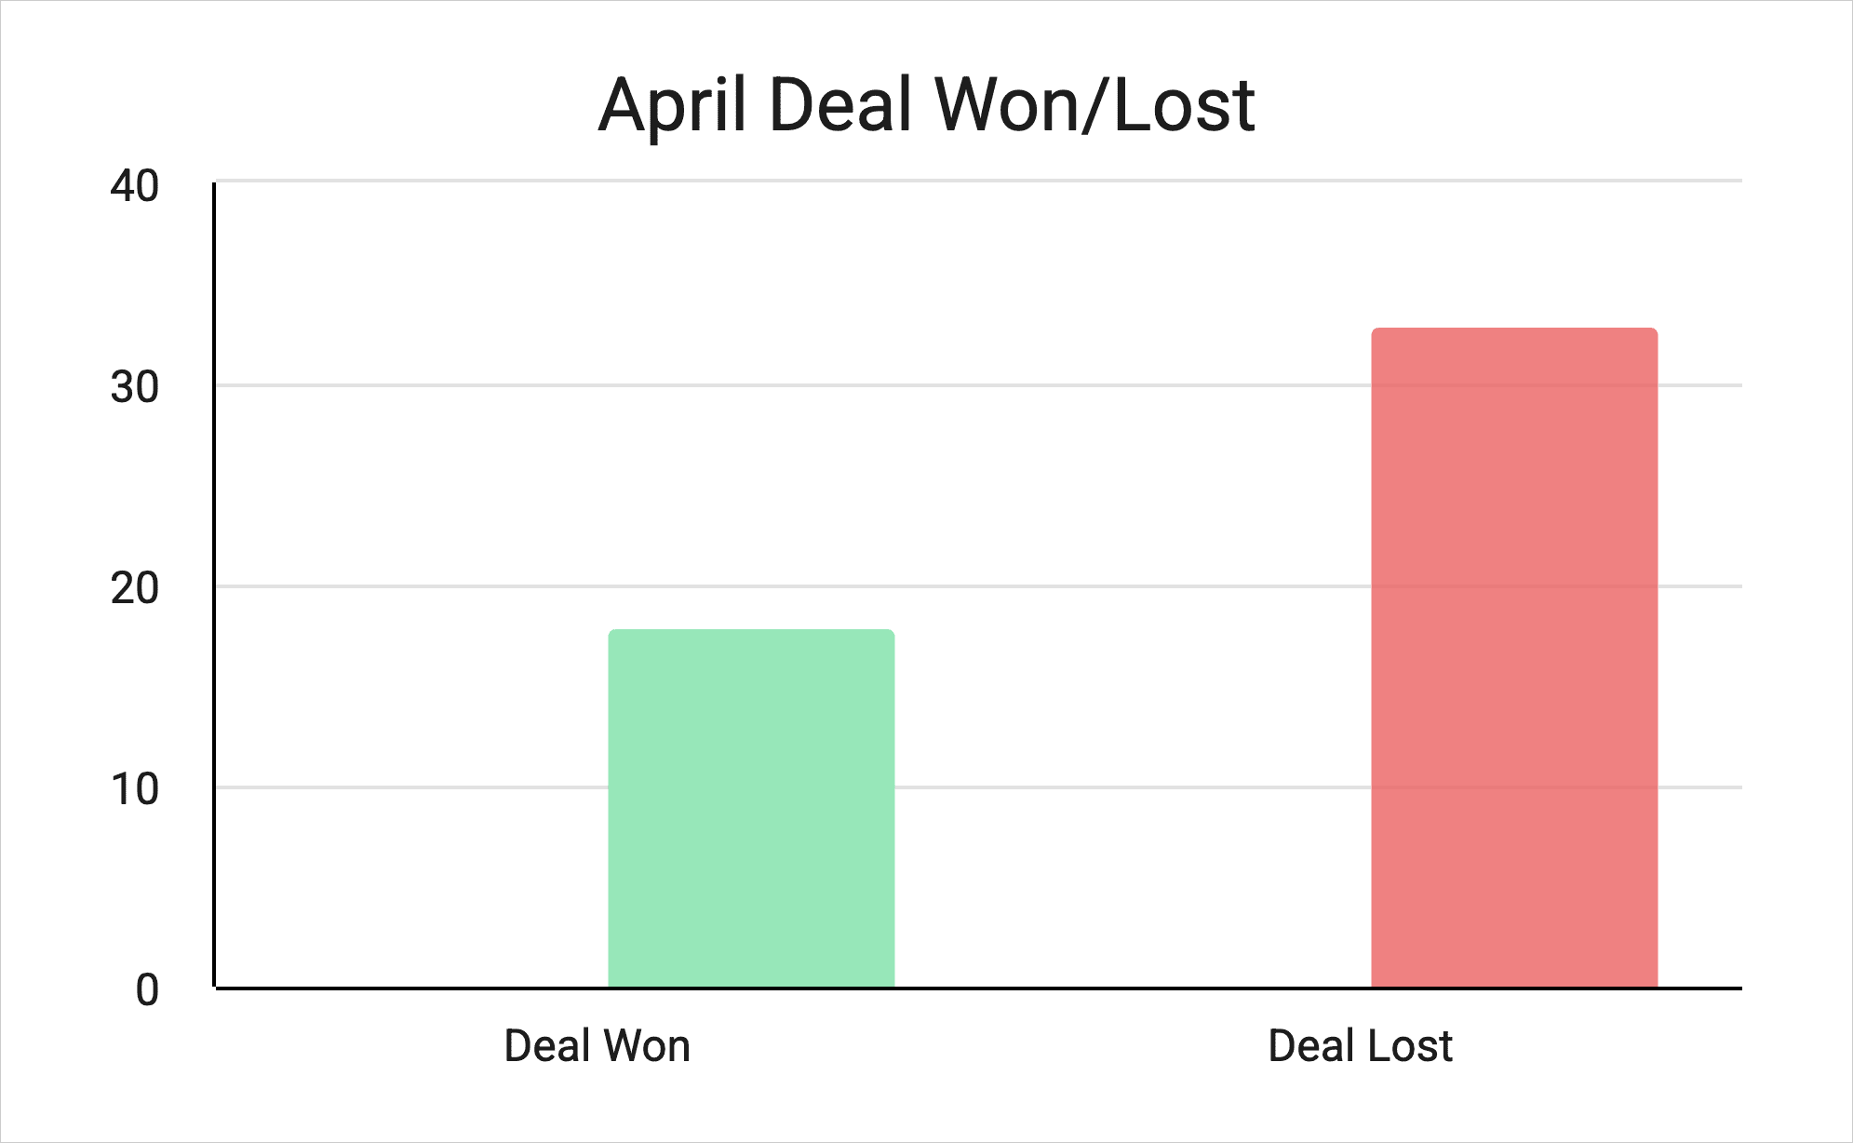

Observation:
- Conversion remained stable with 16 successful closures from 68 active prospects.
- A significant number of opportunities are still in progress, indicating potential carry-forward pipeline into upcoming months.
- Enterprise prospects showed stronger interest in workflow automation and compliance-related use cases.
- Follow-up consistency remains important, as several prospects are still under evaluation stages.

Repeat Engagement Performance:
This section represents prospects who were initially engaged in previous months or prior years and re-entered the evaluation or discussion cycle during April 2026.
Metric | Count
Previously Engaged Prospects | 18
Deal Won | 7
Deal Lost | 6
In Progress | 1
Conversion % | 50%
Deal Size Distribution – Demo Analysis:
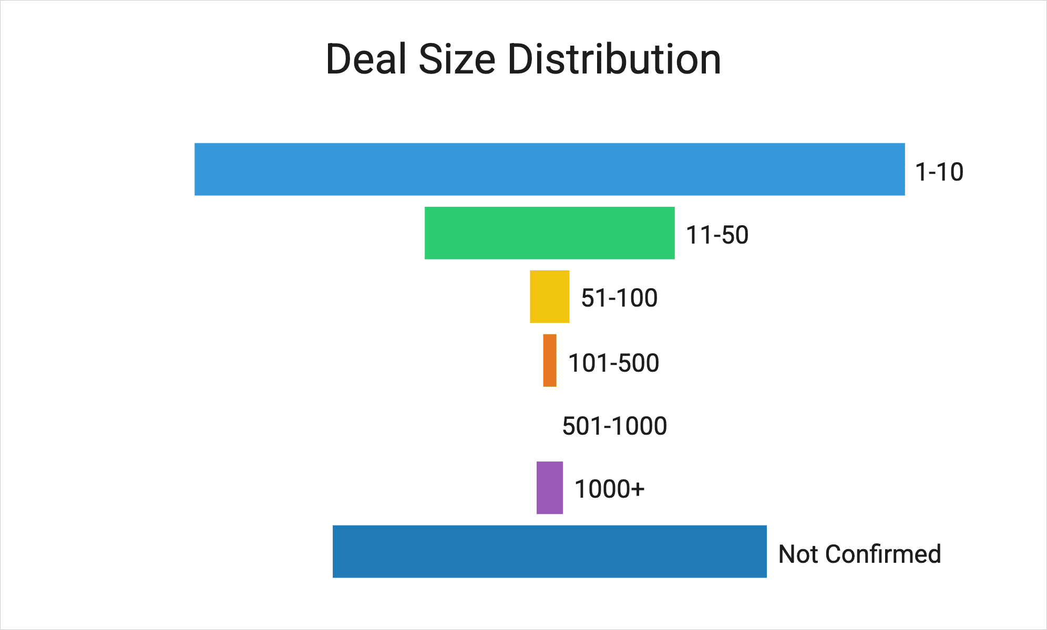

Observation:
- Majority of demos were concentrated in the smaller deal-size segments (1–10 and 11–50 users).
- Enterprise-level opportunities above 500 users remained fewer in count but carried higher strategic value.
- Several opportunities were still marked as “Not Confirmed,” indicating early-stage qualification discussions.

Deal Lost Analysis:
Metric | Count
Loss Rate (Lost / Total Prospects) | 54%

Loss category | Count | % of total lost
No response after multiple follow-ups | 18 | 54.55%
Delayed decision / follow-up later | 4 | 12.12%
Pricing concern (add-on storage cost) | 2 | 6.06%
Prospect not interested post intro / demo | 2 | 6.06%
Prospect purchased subscription independently | 1 | 3.03%
Staying with existing solution | 1 | 3.03%
Looking for other Zoho product (Workplace) | 1 | 3.03%
Internal evaluation delay (trial extended / waiting) | 1 | 3.03%
New requirement not met (unresolved gap) | 3 | 9.09%
Total | 33 | 100%

Requirement | Ticket
Integration with Compute Office | #157176847
Custom roles and permissions | #157476921
Integration with Zoho Books for document workflows | #157533253
End-to-end automation (ingest → process → push back) | #157533253
Figma file (.fig) preview support for approvals workflow | #157838417
Document reminders | #158148360
Page-level search navigation | #109352167
WorkDrive–Workline integration via API | #156552609
Affordable storage add-on pricing | #157891018

Observations:
- More than half of the lost opportunities were due to no response even after multiple follow-ups.
- Delayed decision-making and extended evaluation cycles contributed to additional deal loss scenarios.
- Pricing concerns and existing solution dependency accounted for only a small portion of the overall losses.
- Most lost deals were due to feature limitations as well.

Other Case Breakdown:
Category | Count
New Prospects | 68
Repeat Engagements | 17
Free Org | 2
Existing Org | 9
No Scope | 5

Observation:
- New prospects formed the majority of overall engagements during April.
- Repeat engagements continued steadily, showing sustained follow-up activity with previously engaged prospects.
- Existing organization requests primarily focused on workflow enhancements and integration requirements.
- Very few cases were categorized as out-of-scope requests.

Region-Wise Performance (Based on New Prospects): Feb 2026

Region | Total Deals | Deal Won | Deal Lost
IN | 50 | 12 | 25
US | 9 | 2 | 6
EMEA | 5 | 2 | 2
ANZ | 0 | 0 | 0
APAC | 1 | 0 | 0
EU | 3 | 2 | 0

Observation:
- India contributed the highest number of opportunities and overall deal closures during April.
- US and EMEA regions maintained stable conversion performance with lower deal-loss ratios.
- APAC and ANZ regions had comparatively lower engagement volumes during the month.
- Regional enterprise discussions were mainly centered around migration, compliance, and sharing controls.

Deal Source Analysis:

Source | Count
WorkDrive – Book a Demo | 57
From Sales End | 27
WD Live Support | 16
Internal Loop | 3
Direct Mail to Presales | 2

Observation
- “Book a Demo” remained the primary lead source contributing the highest number of opportunities.
- Sales-referred opportunities continued to contribute significantly to enterprise discussions.
- Live support channels also played an important role in generating qualified engagements.
- Direct outreach and internal referrals contributed comparatively fewer leads.

Requests Handled:
Channel | Count
Emails | 556
Demos | 106
Calls | 117

Feature Demand Analysis:
Workflow Enhancements:

Feature Name | Feature Description | Ticket ID | Sprint Link
Advanced Workflow Analytics Dashboard | Centralized project-wise and overall workflow dashboard with pending internal/client approvals, overdue tracking, pending submissions, and reporting integration support via Zoho Analytics or Zoho Creator. | #157238382 | https://sprints.zoho.in/workspace/zdocs#P15/itemdetails/I8296
Workflow Due Date Tracking | Centralized tracking view for files that crossed due dates along with pending workflow participants. | #149970514 | https://sprints.zoho.in/workspace/zdocs#P15/itemdetails/I8297
Expiry Tracking & Alerts | Expiry tracking with automated alerts to support expiry workflows, notifications, and document validation. | #158062577 | https://sprints.zoho.in/workspace/zdocs#P15/itemdetails/17850
Long-Term Document Reminder Workflow | Long-term recurring document reminder workflows for approvals, renewals, and policy tracking. | #158148360 | https://sprints.zoho.in/workspace/zdocs#P15/itemdetails/17858
Policy Renewal Reminder Workflow | Automated policy renewal reminder workflows with version update tracking support. | #158466041 | https://sprints.zoho.in/workspace/zdocs#P15/itemdetails/17885
Workflow Audit Trail Embedding | Automatically capture workflow activity logs in a structured table format and embed them within the final approved document. | #155995585 | Supported through custom functions.

External Integrations & Migration:

Feature Name | Feature Description | Ticket ID | Sprint Link
SharePoint Migration Support | Native migration support for transferring SharePoint data, structure, and permissions into Zoho WorkDrive for enterprise migration use cases. | #158978615 | https://sprints.zoho.in/workspace/zdocs#P15/itemdetails/17689/description
Forcepoint DLP Integration | Integration capability between Zoho WorkDrive and Forcepoint DLP for enterprise-grade data loss prevention and compliance monitoring. | #158978615 | https://sprints.zoho.in/workspace/zdocs#P15/itemdetails/17467/description
GTB DLP Integration | Integration support with GTB DLP for enterprise compliance workflows, including alerts/notifications when users attempt to share DLP-classified files. | #153970357 | https://sprints.zoho.in/workspace/zdocs#P15/itemdetails/18081
DLP Share Attempt Alerts | Alerts/notifications for failed DLP share attempts and classified file-sharing activities. | #153970357 | https://sprints.zoho.in/workspace/zdocs#P15/itemdetails/18082
Zoho Books Integration | Integration with Zoho Books for document workflow confirmations and end-to-end automation support. (ingest → process → push back to system) | #157533253

Security, Sharing & Permissions:

Feature Name | Feature Description | Ticket ID | Sprint Link
Advanced Sharing Restrictions | Ability to disable org-wide link-based internal sharing (“Anyone on the team”) and enforce email-based internal sharing only. | #158978615 | https://sprints.zoho.in/workspace/zdocs#P15/itemdetails/18062
Custom Roles & Permissions | User-based advanced custom Team folder roles and permissions management for enterprise-level access control. | #157476921 | https://sprints.zoho.in/workspace/zdocs#P15/itemdetails/I546
Team Folder Storage Quota | Storage quota management at Team Folder level. | #157843287 | https://sprints.zoho.in/workspace/zdocs#P15/itemdetails/17765

AI & Intelligent Features:

Feature Name | Feature Description | Ticket ID | Sprint Link
Gemini AI Integration | Integration support for Google Gemini Enterprise as the LLM provider for AI-powered capabilities across WorkDrive and Workplace applications. | #158978615 | https://sprints.zoho.in/workspace/zdocs#P15/itemdetails/18064
Advanced Document Search | Search capability to navigate to the exact page directly, section, or transaction within large documents based on keywords or vendor names. | #109352167 | https://sprints.zoho.in/workspace/zdocs#P15/itemdetails/17875

Feature Trend Observations:
- Workflow enhancements remained the most requested category, especially around reminders, escalations, approvals, and tracking.
- Enterprise customers showed strong demand for DLP integrations, migration capabilities, and advanced sharing controls.
- Search improvements and AI-powered capabilities gained increased interest from enterprise prospects.
- Customers increasingly expect WorkDrive to function as a centralized workflow and compliance management platform beyond standard document storage capabilities.

